2024 BACK TO SCHOOL READY SET GO AND STUFF THE BUS

AGAIN THIS YEAR, THE READY SET GO FAIR AND MYCITYCARE'S STUFF THE BUS ARE JOINING FORCES TO SERVE FAMILIES OF LETHBRIDGE WITH BACK TO SCHOOL SUPPLIES

IF YOUR CHILDREN ATTEND SCHOOL IN LETHBRIDGE
IF YOU ARE NOT SURE YOU WILL BE ABLE TO AFFORD SCHOOL SUPPLIES

THEN THIS PROGRAM IS FOR YOU

YOU CAN REGISTER : In Person @ Interfaith

Food Bank

In Person @ Lethbridge Food Bank
Online:

Registration Is Open
May 21, 2024

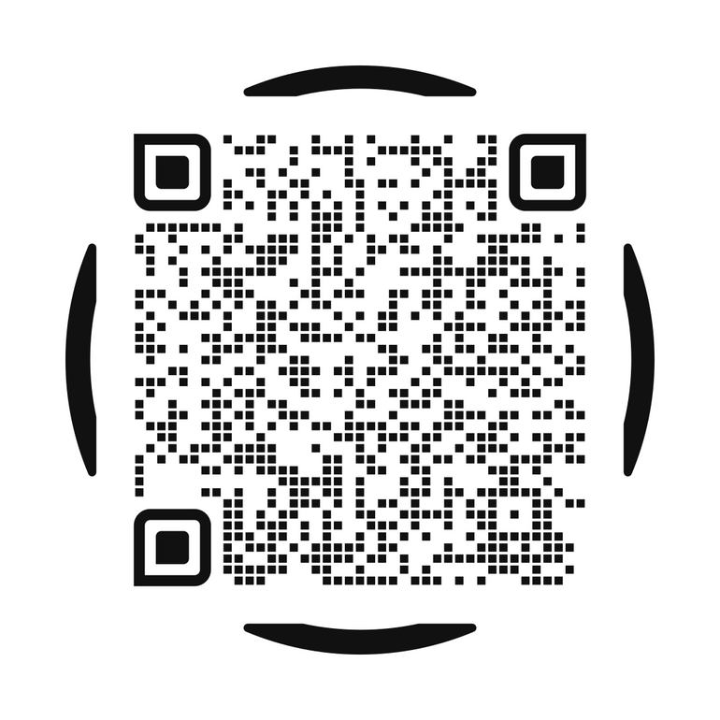
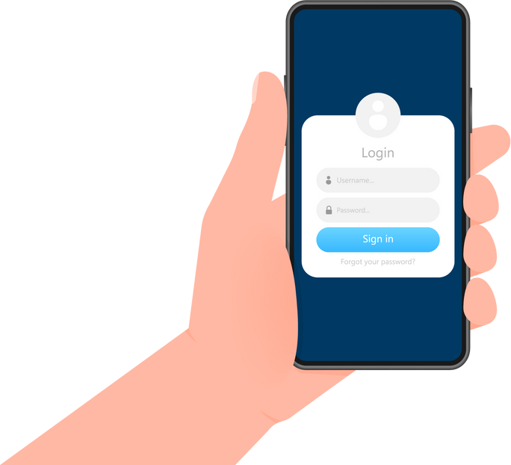
Pick Up is 12pm-6pm
Aug 21- YMCA (74 Mauretania Rd W) Aug 22- CASA (230 8th Street S)

*Just a reminder. Supplies provided will be a standardized set of initial supplies that may or may not correspond with the specific school class supply lists. Some supplies may still be required.

